7KEX -

Functionality
For planning with integrated Excel, Microsoft Excel is used as a planning screen for planning in the SAP System. This allows you to combine the comfort of Excel's formatting and data processing functions with the powerful planning functions of your SAP application. You are therefore able to use the Office input interface with online planning in the SAP System.
There are two ways of using Excel to plan your data:
- Planning with Excel integrated into the user interface of the SAP System Excel replaces the standard SAP planning screen. This enables you to plan using the functions of both the SAP System and Excel.
- Offline planning in Excel and uploading data into the SAP System from one or more PCs that are not connected to the SAP System, you can enter your planning data into several Excel spreadsheets. This data can then be uploaded into the SAP System, where you can process it further using the SAP planning functions.

Scenario
Upload Excel Sheet containing planning values to the SAP system

Requirements
Excel application.

Menu Path | Accounting → Controlling → Profit Center Accounting → Planning → Plan Data Transfer → KE1V - Costing-based CO-PA → Upload from Excel → 7KEX - Execute
Transaction Code | 7KEX

1. Double Click on 7KEX – Execute.

EC-PCA Planning: Upload from Microsoft Excel

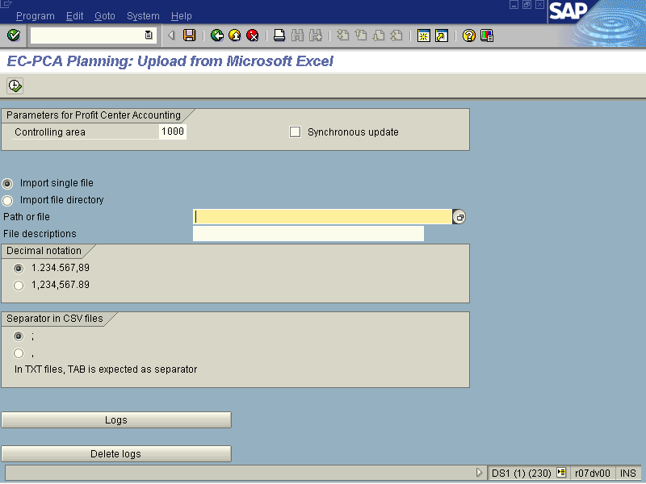
2. Press [F4] or Click the Search button in the Path or file field.

File selection

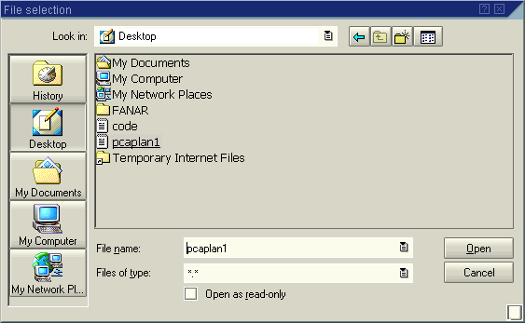
3. Enter the file name or select it from the directory in windows.
4. Click Open Button .
EC-PCA Planning: Upload from Microsoft Excel

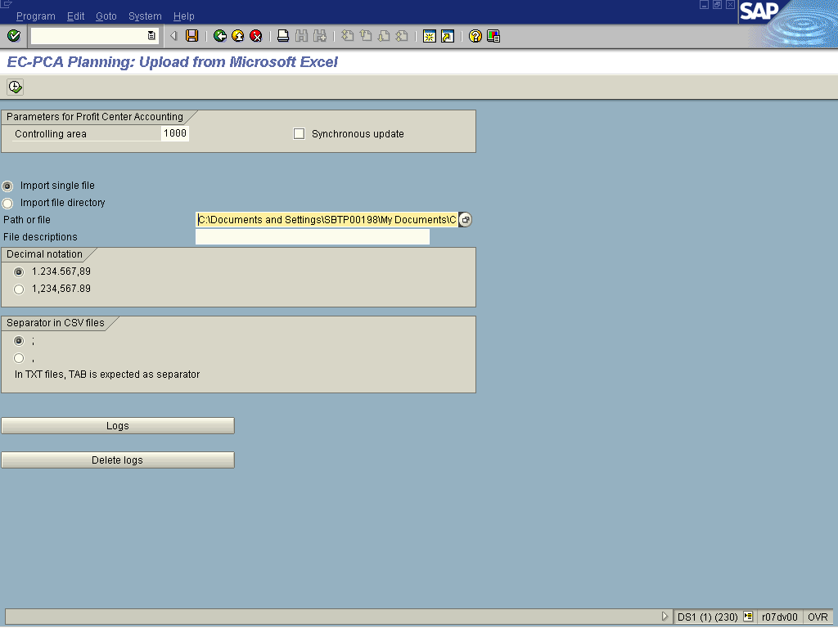

5. Click Execute .

EC-PCA Planning: Upload from Microsoft Excel

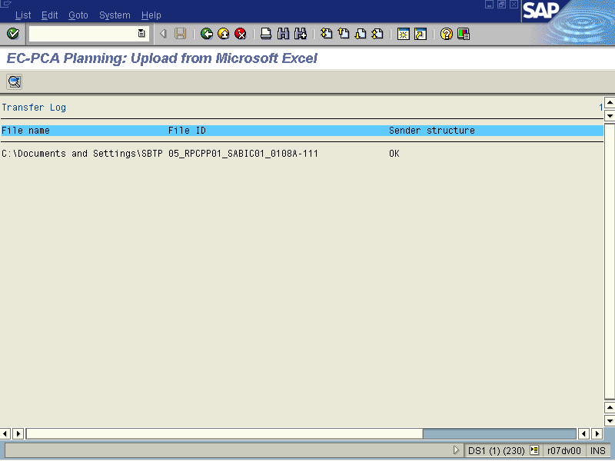

6. The system displays a status report of the uploaded data.

